Memorandum

To: JRPP

From: Kathleen Taminiau

File: DA 110 20/21

Date: 20/07/2021

Re: PPSNTH-93 - Suggested amended conditions for the proposed solar project, Tuttles Lane, Glen Innes.

***Comments:***

* The applicant has reviewed the proposed conditions in the draft conditions of consent.
* The applicant has requested the determining authority consider amending two (2) conditions.
* Council has considered the request and accompanying revised visual analysis, landscape concept plan and reflectivity statement and are satisfied with the proposed amendments subject to the applicant furnishing a schedule of finishes for approval prior to the release of a Construction Certificate.

***Suggested amended Conditions:***

**Condition 11 Low Reflective Materials**

Materials and their finishes/colours of any proposed or future buildings, security fencing or structures are to be selected to be of a natural colour palette and low reflectivity

**Applicant Response:** The applicants accepts this condition. The applicant would like to suggest the terminology be changed to the following:  
  
*‘Materials and their finishes/colours of any proposed or future buildings, security fencing or structures are to be selected to be of a natural colour palette* ***where practicable*** *and low reflectivity* ***where practicable****.’*

**Council response:** *Council has considered the applicants request and are satisfied with the proposed amendments subject to the inclusion of the following:*

*A schedule of finishes it to be provided to Council for approval prior to the release of the CC.*

**Condition 15 Landscaping**

The landscaping is to be implemented generally as shown on the Landscape Plan and must include:

- A 3 to 4 metre wide landscaped buffer to all sides of the lease boundary (not just the eastern and southern sides of the lease area).

- A water supply (tank water) to allow regular watering of the landscaped buffer.  The water supply may be supplemented with tanker delivery as required.

**Applicant Response:** As highlighted in the updated Landscape Concept Plan, as a result of elevations and existing obstructions, a landscape buffer on the Northern Side would not be required as the receptor sensitivity from View Point 6 on Abbotts Road is considered low with minor impact significance. The applicant would like to suggest the following amended to **Condition 15**:

*The landscaping is to be implemented generally as shown on the Landscape Plan and must include:*

*- A 3 to 4 metre wide landscaped buffer to the* ***Eastern, Southern and Western side of the lease boundary****.*

*- A water supply (tank water) to allow regular watering of the landscaped buffer.  The water supply may be supplemented with tanker delivery as required*.

**Council response:** *Council has considered the applicants updated Visual Analysis, Landscape Concept and Reflectivity Statement Plan and are satisfied with the proposed amendment to condition 15 to remove the landscape buffer requirement from the northern boundary of the lease area.*

*Figure 1 below shows the subject site along the eastern side of Tuttles Lane and the topography of the land directly to the north of the proposed solar project. It is considered that the vegetated hill will provide adequate screening of the panels from any sensitive receptors on this side.*

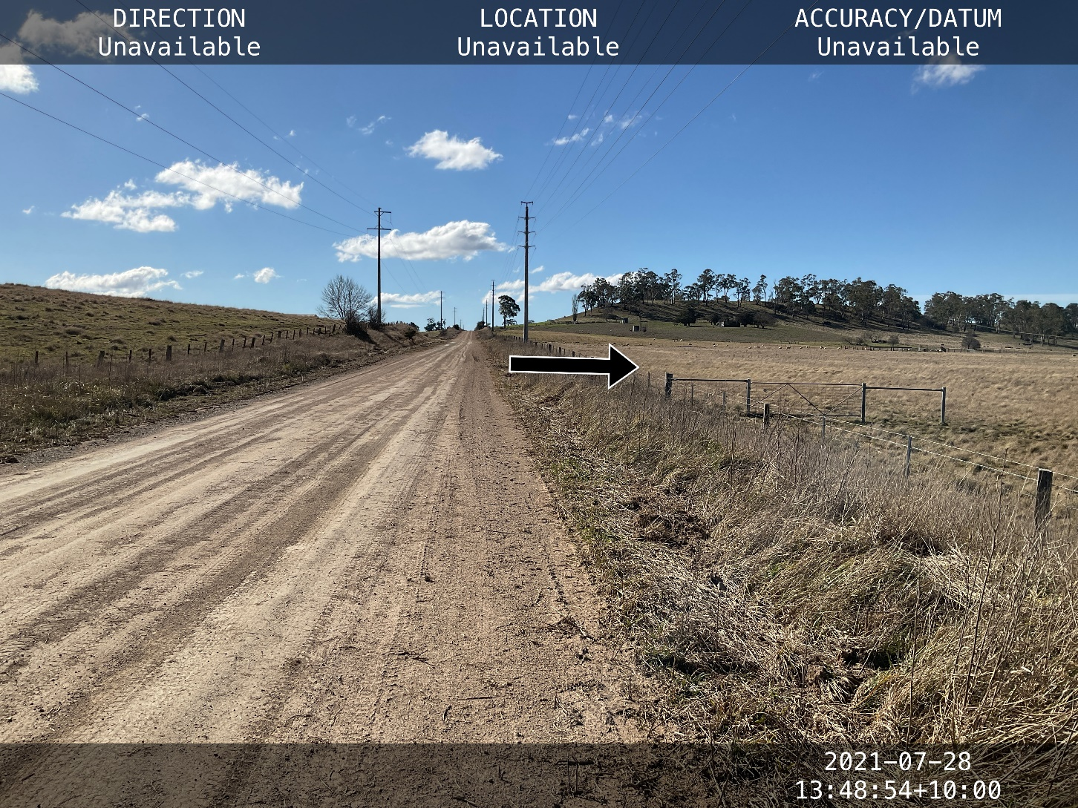

Figure - Looking north along Tuttles Lane showing subject site to the right (east) and surrounding vegetation and topography. Source: Glen Innes Severn Council

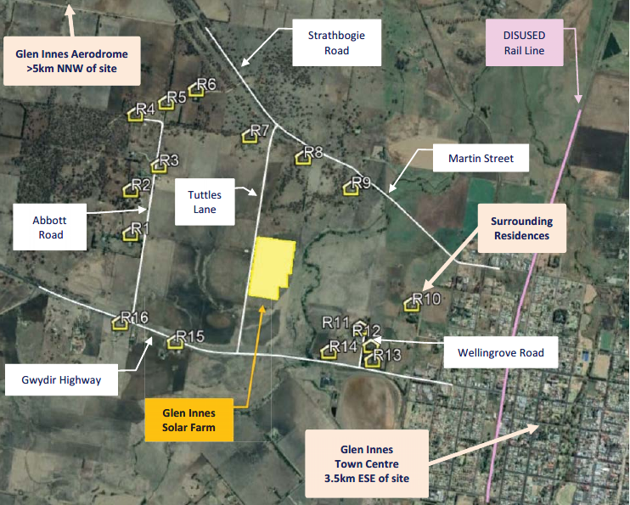

Figure - Aerial view of showing footprint of proposed solar project and surrounding sensitive receptors Source: SLR Consulting